Test Case: tc001_SPX_Dev5_Crear_Nueva_Linea_Requisicion_Spot_Tipo_Cobro_CC
Step 1 - Enter username and password and click to button Enter : Credentials Entered
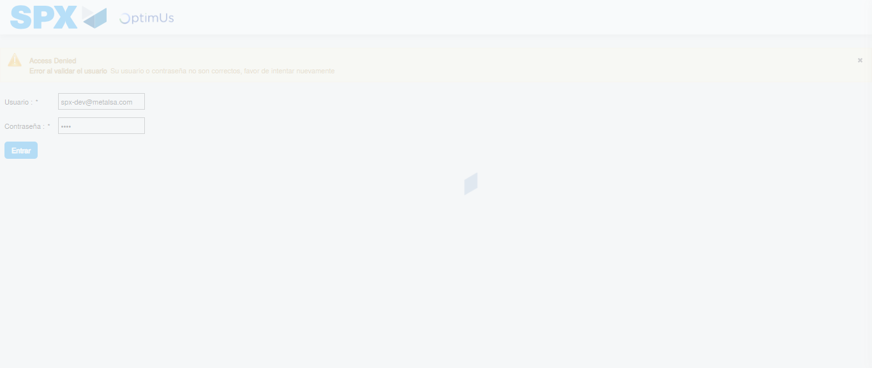Image file-name: QC_Testing-tc001_SPX_Dev5_Crear_Nueva_Linea_Requisicion_Spot_Tipo_Cobro_CC-1790177110315

Step 2 - Select to UEN and Access to Spot Buy Requisitions : UEN Correctly selected and Correct access
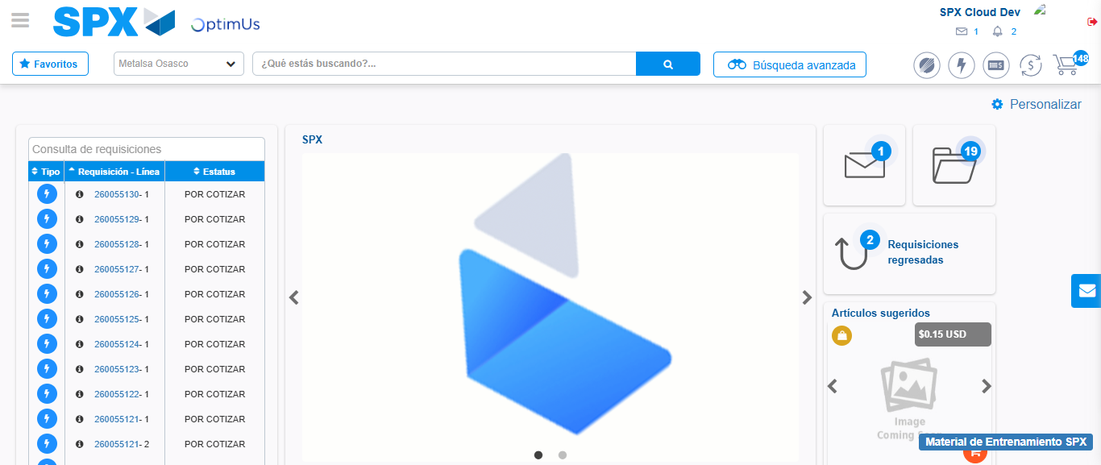Image file-name: QC_Testing-tc001_SPX_Dev5_Crear_Nueva_Linea_Requisicion_Spot_Tipo_Cobro_CC-1790177147968

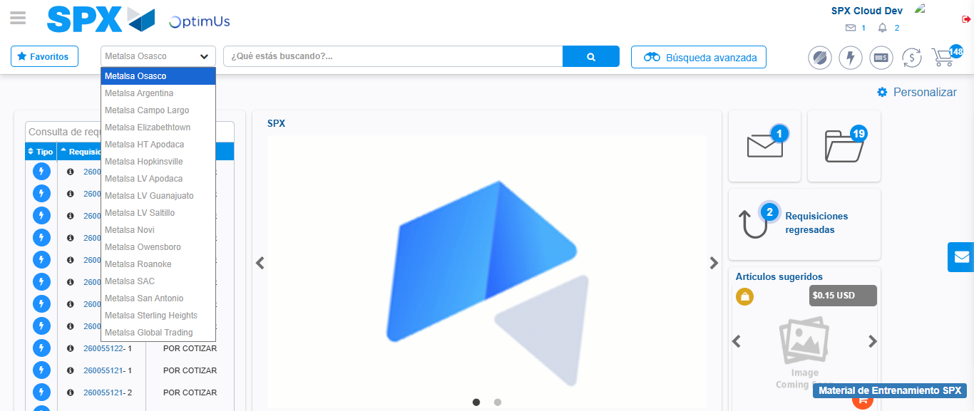Image file-name: QC_Testing-tc001_SPX_Dev5_Crear_Nueva_Linea_Requisicion_Spot_Tipo_Cobro_CC-1790177148679

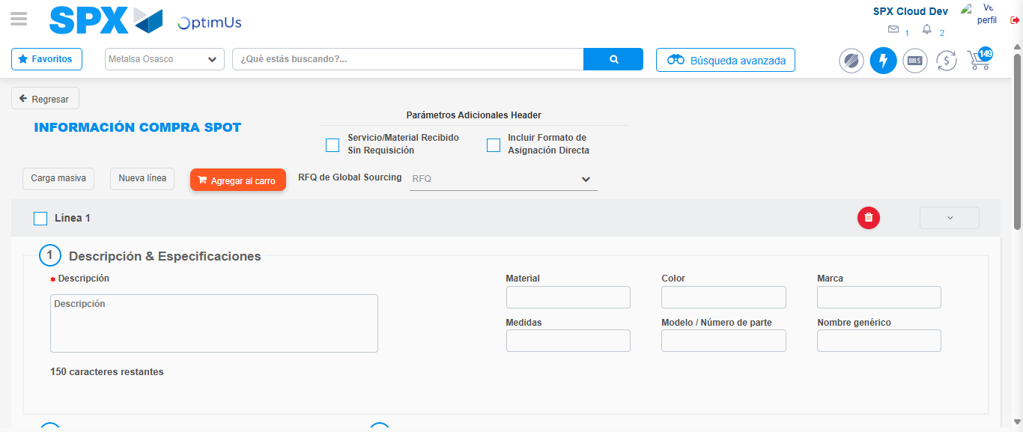Image file-name: QC_Testing-tc001_SPX_Dev5_Crear_Nueva_Linea_Requisicion_Spot_Tipo_Cobro_CC-1790177153348

Step 3 - Data Capture Spot Buy Requisition: Data captured correctly
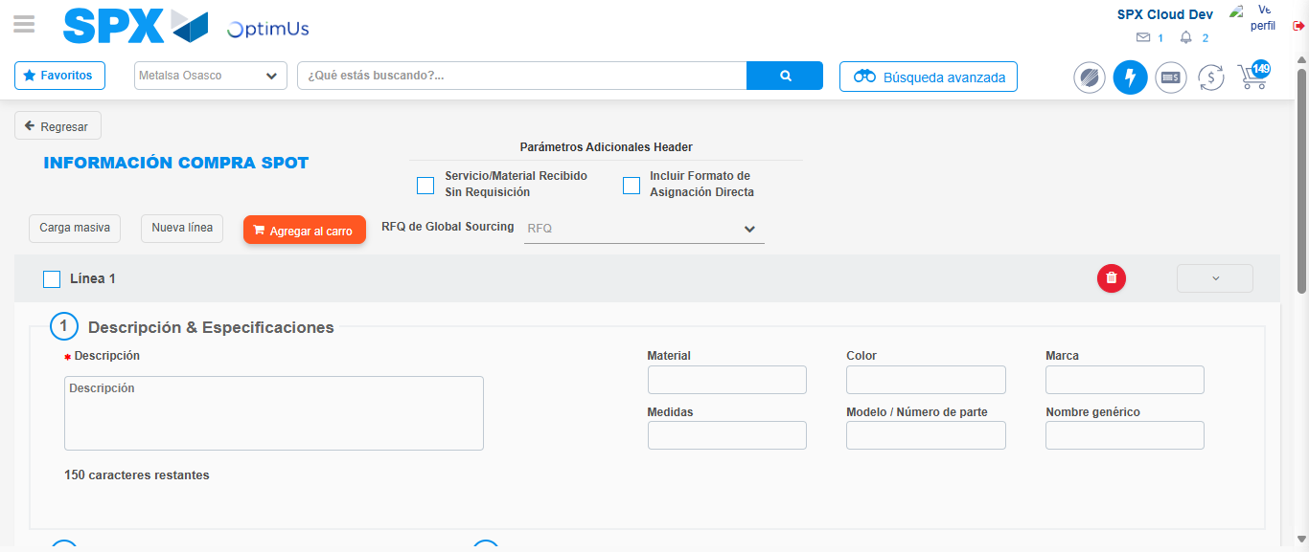Image file-name: QC_Testing-tc001_SPX_Dev5_Crear_Nueva_Linea_Requisicion_Spot_Tipo_Cobro_CC-1790177153622

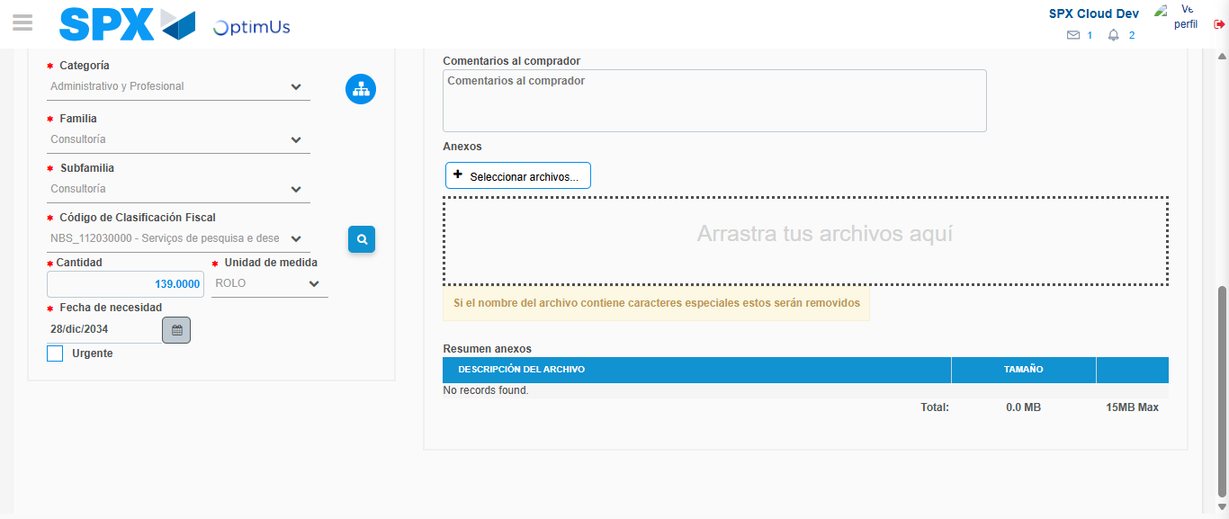Image file-name: QC_Testing-tc001_SPX_Dev5_Crear_Nueva_Linea_Requisicion_Spot_Tipo_Cobro_CC-1790177170675

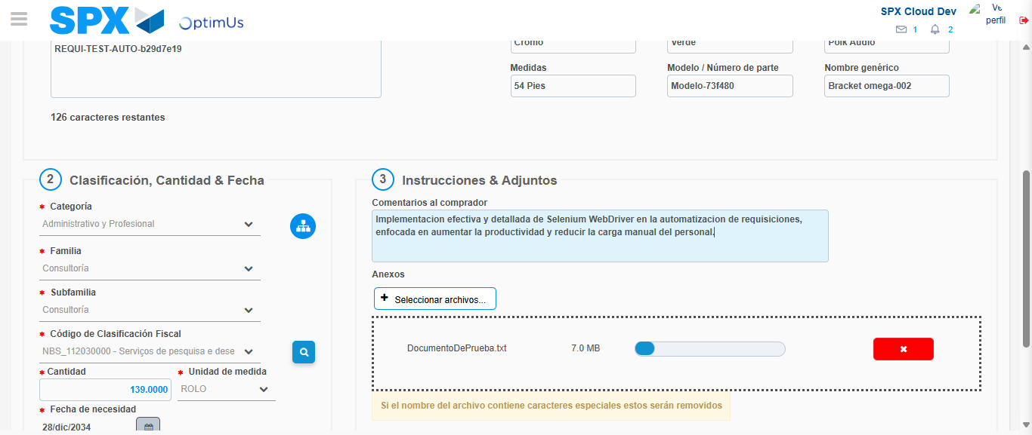Image file-name: QC_Testing-tc001_SPX_Dev5_Crear_Nueva_Linea_Requisicion_Spot_Tipo_Cobro_CC-1790177171725

Step 4 - Add new line and data capture second line: Line add correctly
Image file-name: QC_Testing-tc001_SPX_Dev5_Crear_Nueva_Linea_Requisicion_Spot_Tipo_Cobro_CC-1790177153622

Image file-name: QC_Testing-tc001_SPX_Dev5_Crear_Nueva_Linea_Requisicion_Spot_Tipo_Cobro_CC-1790177170675

Image file-name: QC_Testing-tc001_SPX_Dev5_Crear_Nueva_Linea_Requisicion_Spot_Tipo_Cobro_CC-1790177171725

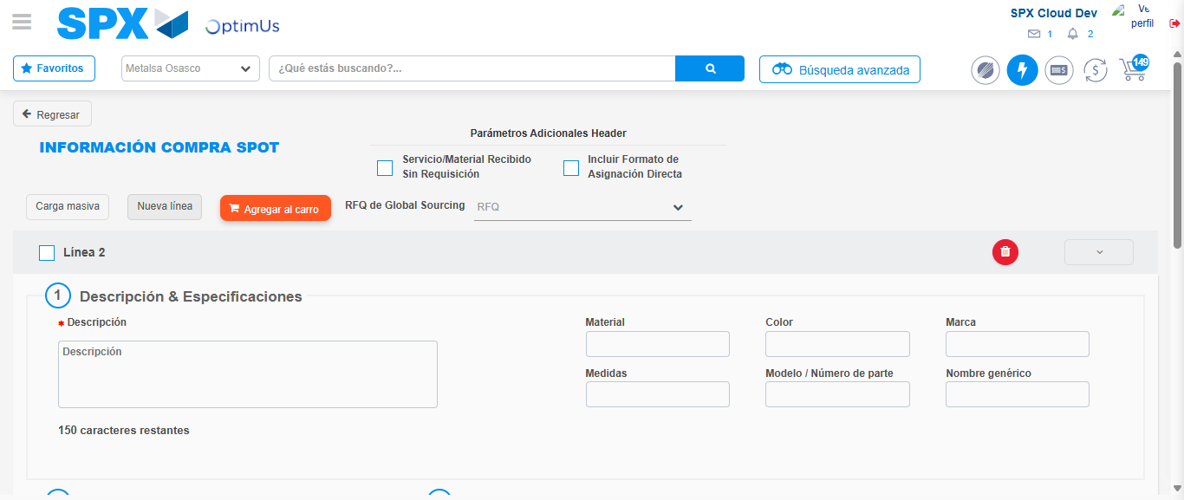Image file-name: QC_Testing-tc001_SPX_Dev5_Crear_Nueva_Linea_Requisicion_Spot_Tipo_Cobro_CC-1790177174152

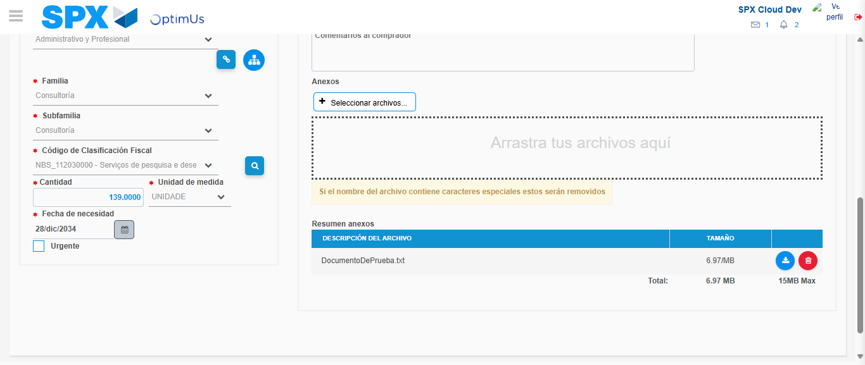Image file-name: QC_Testing-tc001_SPX_Dev5_Crear_Nueva_Linea_Requisicion_Spot_Tipo_Cobro_CC-1790177193306

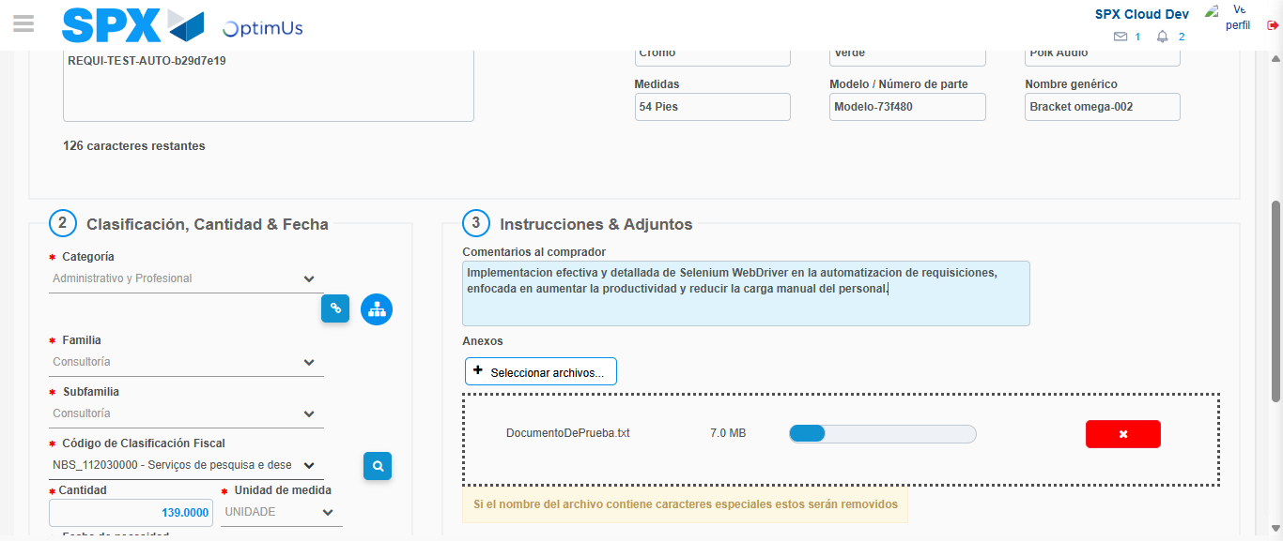Image file-name: QC_Testing-tc001_SPX_Dev5_Crear_Nueva_Linea_Requisicion_Spot_Tipo_Cobro_CC-1790177194329

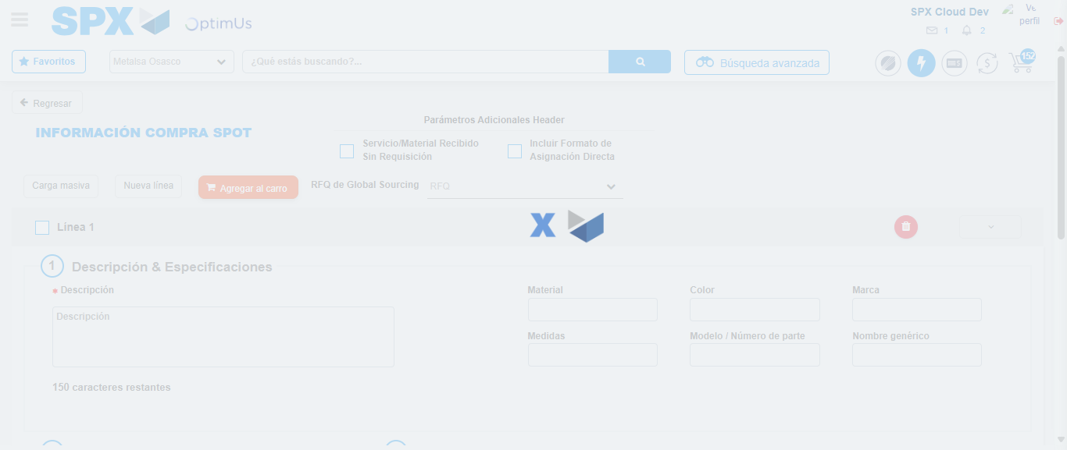Image file-name: QC_Testing-tc001_SPX_Dev5_Crear_Nueva_Linea_Requisicion_Spot_Tipo_Cobro_CC-1790177207282

Step 8 - Return to Main Page SPX : Return to Main Page SPX
Image file-name: QC_Testing-tc001_SPX_Dev5_Crear_Nueva_Linea_Requisicion_Spot_Tipo_Cobro_CC-1790177147968

Image file-name: QC_Testing-tc001_SPX_Dev5_Crear_Nueva_Linea_Requisicion_Spot_Tipo_Cobro_CC-1790177148679

Image file-name: QC_Testing-tc001_SPX_Dev5_Crear_Nueva_Linea_Requisicion_Spot_Tipo_Cobro_CC-1790177153348

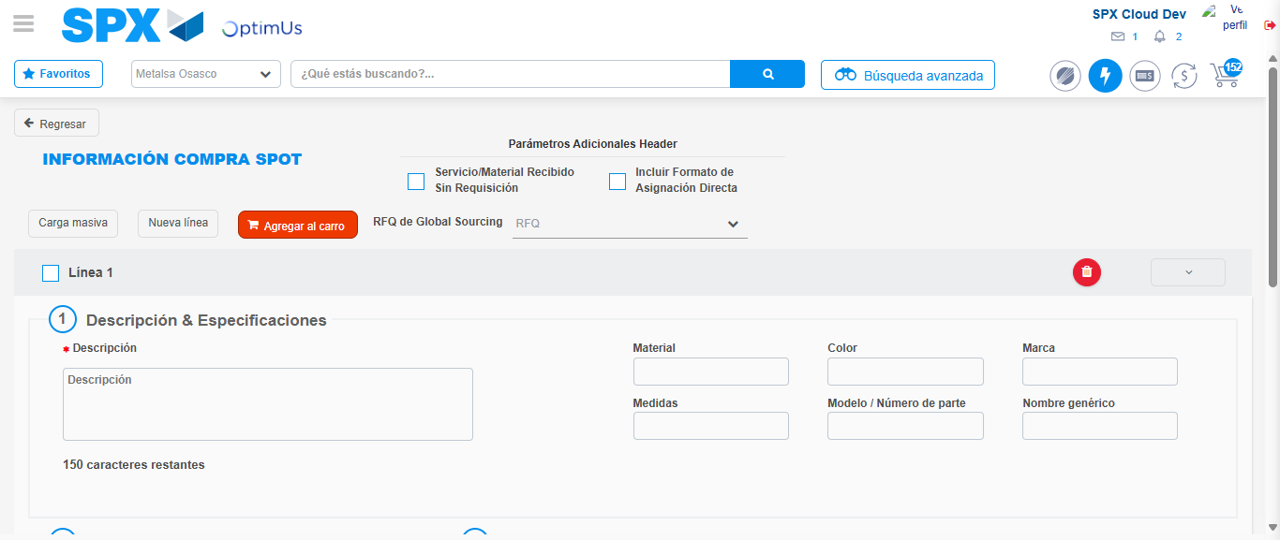Image file-name: QC_Testing-tc001_SPX_Dev5_Crear_Nueva_Linea_Requisicion_Spot_Tipo_Cobro_CC-1790177209518

Image file-name: QC_Testing-tc001_SPX_Dev5_Crear_Nueva_Linea_Requisicion_Spot_Tipo_Cobro_CC-1790177209693

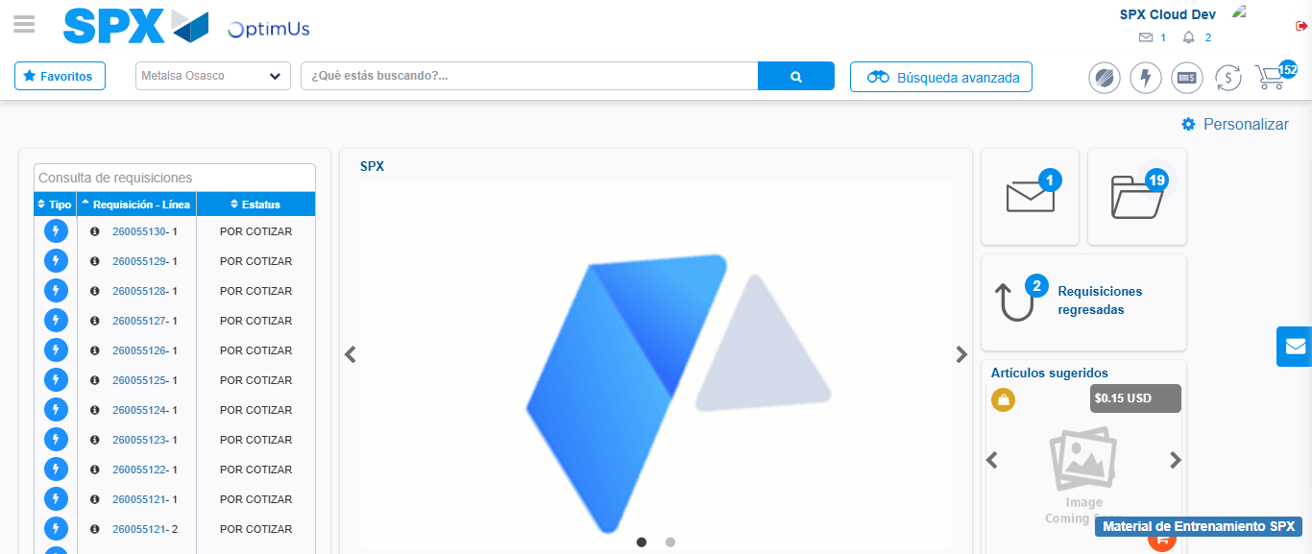Image file-name: QC_Testing-tc001_SPX_Dev5_Crear_Nueva_Linea_Requisicion_Spot_Tipo_Cobro_CC-1790177231193

Step 9 - Log Out : Log Out SPX
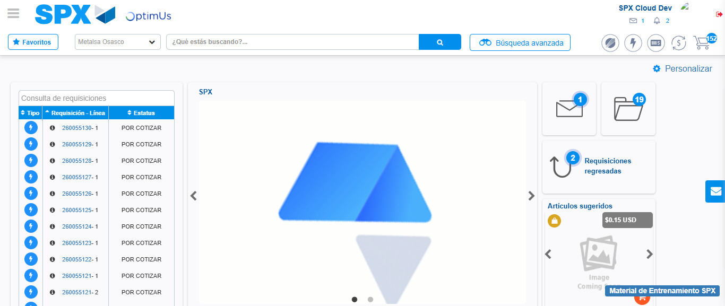Image file-name: QC_Testing-tc001_SPX_Dev5_Crear_Nueva_Linea_Requisicion_Spot_Tipo_Cobro_CC-1790177231559

